 |  | Substation |  |  | {{ substation.name_erms }} |  |  |  |  |  |  |  |  |  |  |  |  | Date: {{ substation.date }}
 |  | Equipment |  |  | {{ swg.type }} |  | Manufacturer |  |  |  |  |  |  |  |  | {{ swg.manufacturer }} |  | Time: {{ substation.time }}
 |  | Model |  |  | {{ swg.model }} |  | Rating |  |  |  |  |  |  |  |  | {{ swg.rating }} |  | Humidity: {{ substation.humidity }}
 |  | Area |  |  | {{ swg.area }} |  |  |  |  |  |  |  |  |  |  | Feeder No. |  | {{ panel.linknumber }}
Feeder Name |  | {{ panel.name }}
 | IR IMAGE |  |  |  |  |  |  |  |  |  |  | VISUAL IMAGE
 | 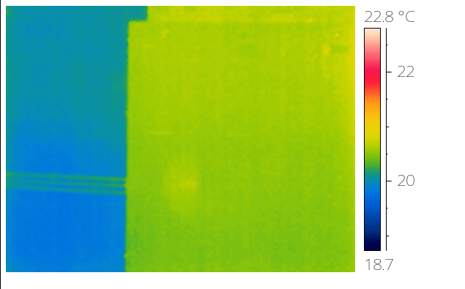 |  |  |  |  |  |  |  |  |  |  | {{visual_image}}
 | PARAMETER |  | VALUE
 | Spot Temp.1 (Sp1) |  | - |  |  |  |  |  |  |  |  |  |  |  | PARAMETER |  |  | VALUE
 | Spot Temp. 2 (Sp2) |  | - |  |  |  |  |  |  |  |  |  |  |  | Serial No. |  |  | {{ panel.serialnumber }}
 | Average Temp. (Ar1) |  | - |  |  |  |  |  |  |  |  |  |  |  | Heater (A) |  |  | {{ panel.heateramp }}
 | Ambient Temp. |  | {{ substation.ambient }} |  |  |  |  |  |  |  |  |  |  |  | CB Position |  |  | {{ panel.breakerstatus }}
 | Delta T ( ∆ T) |  | - |  |  |  |  |  |  |  |  |  |  |  | Busbar Position |  |  | {{ panel.busbarposition }}
 | Load (A) |  | {{ panel.loadamp }} |  |  |  |  |  |  |  |  |  |  |  | Cable Type |  |  | {{ panel.cabletype }}
 | Defect
 | ULTRASOUND IMAGE
 | 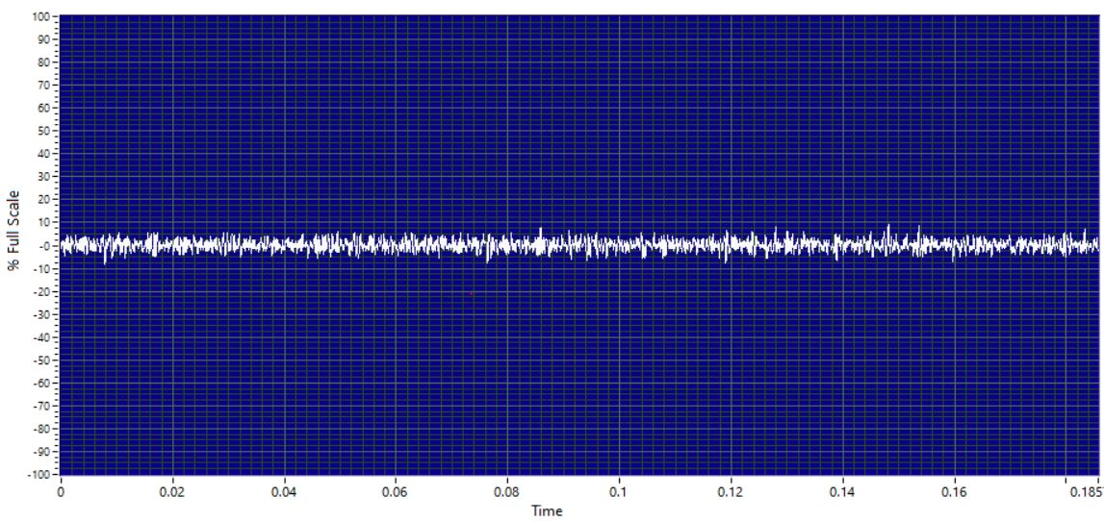
 | Decibel (dB) |  |  | 0dB
 | Sound characteristic |  |  | Normal
 | Severity
 | Sound clip |  |  | 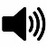
Analysis & Recommendations:
Analysis: No Anomaly.
Recommendation: -

